Working with the String Data Type

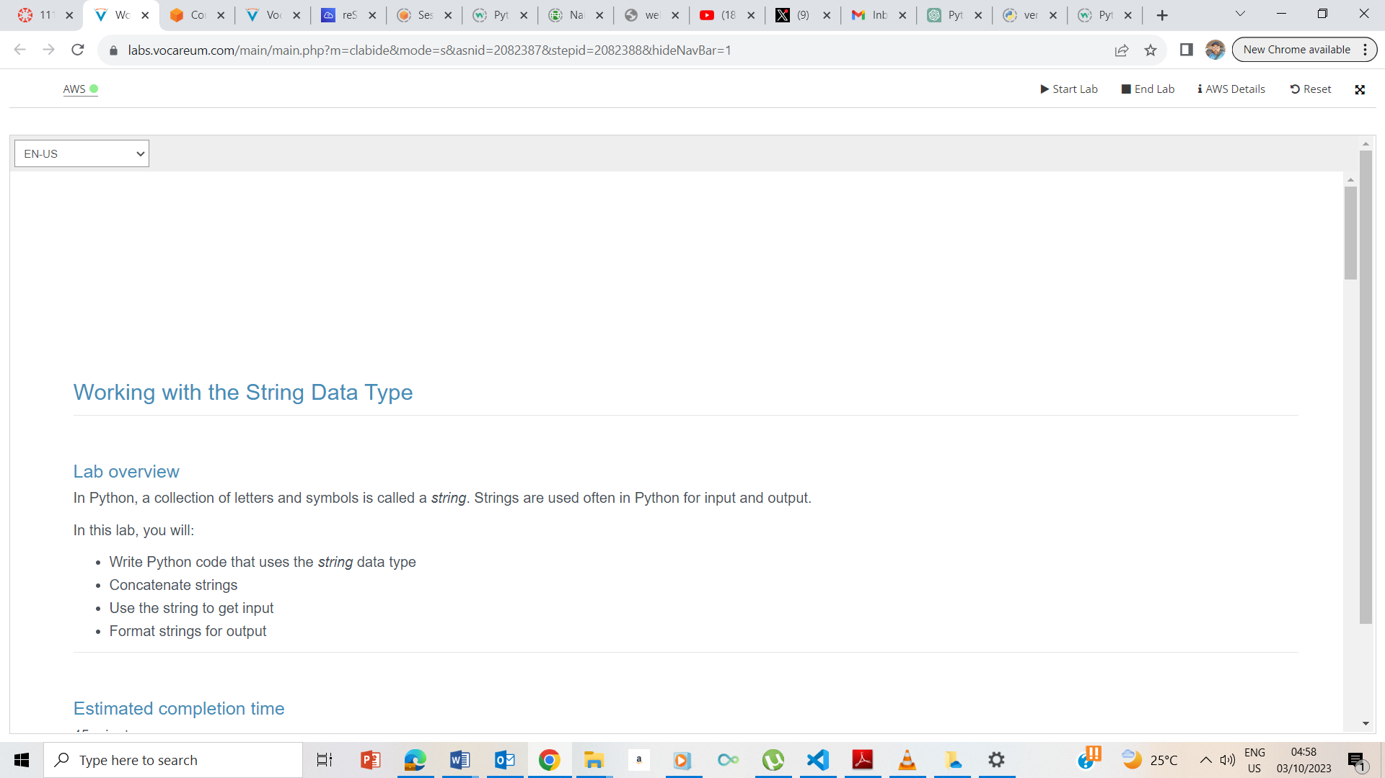

I clicked on the Start button and upon the AWS link turning green, I clicked on it to take me to the AWS management console.

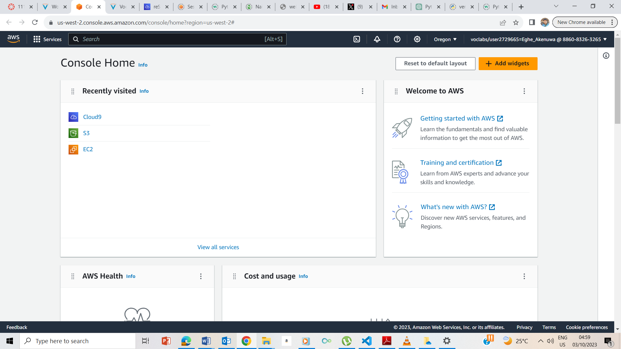

AWS Management Console. I clicked on the Cloud9 to take me to the coud9 page

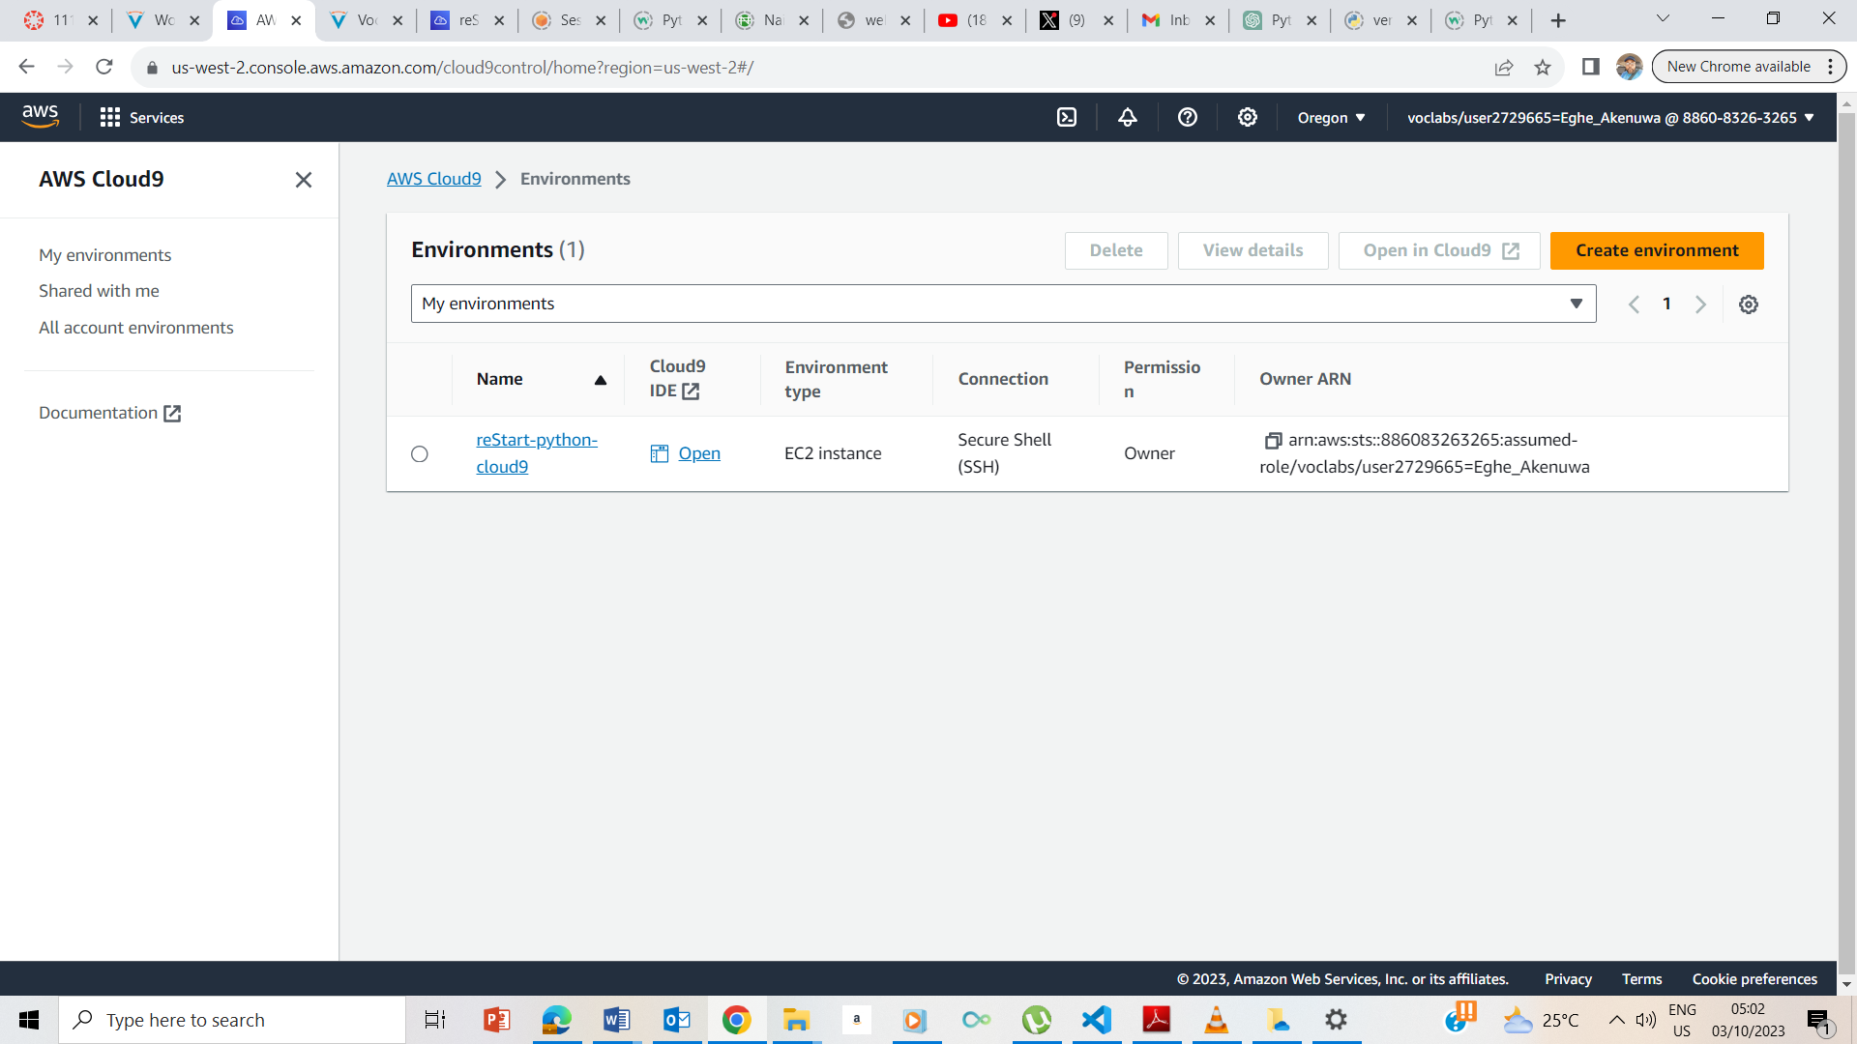The Cloud9 page: I clicked on the Open IDE to take me to the terminal

## **Creating your Python exercise file**

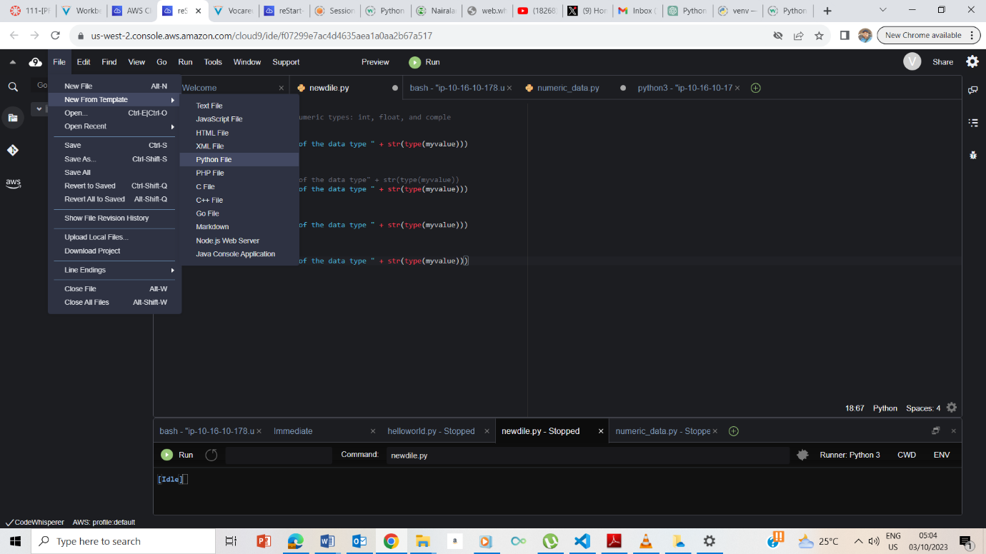

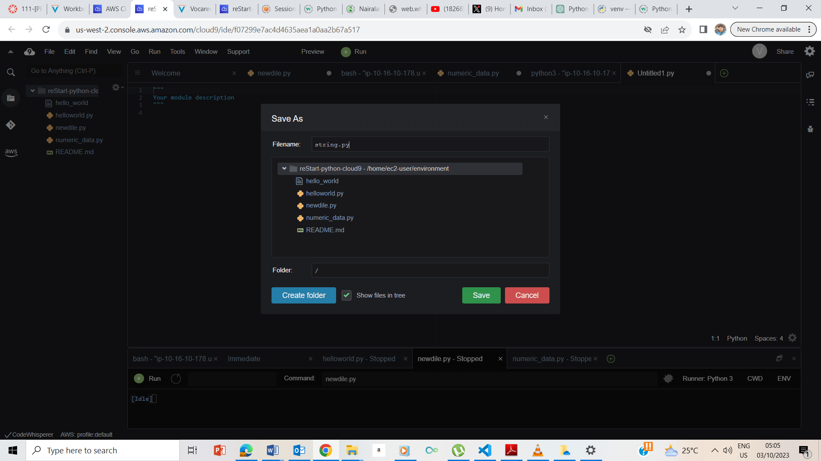

## **Accessing the terminal session**

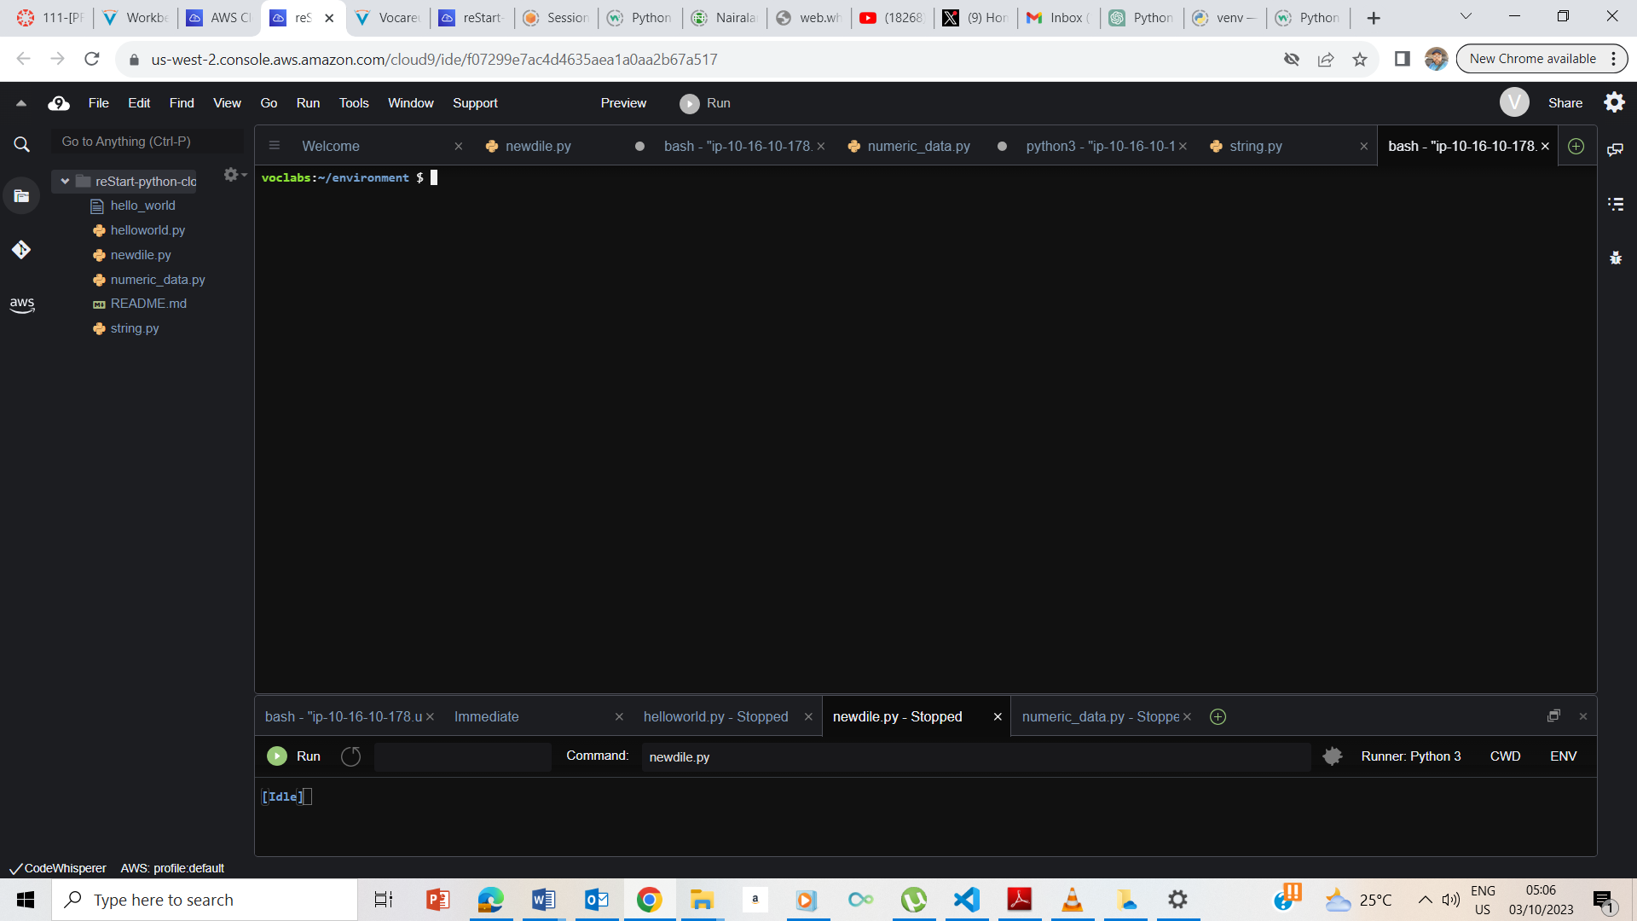

I clicked on the + sign and choosed New Terminal

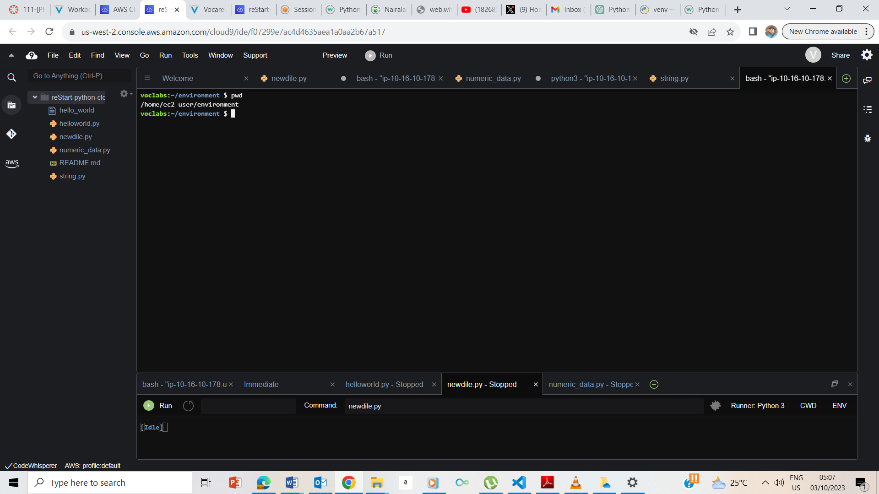

Pwd chows me I am in the environment

## **Exercise 1: Introducing the string data type**

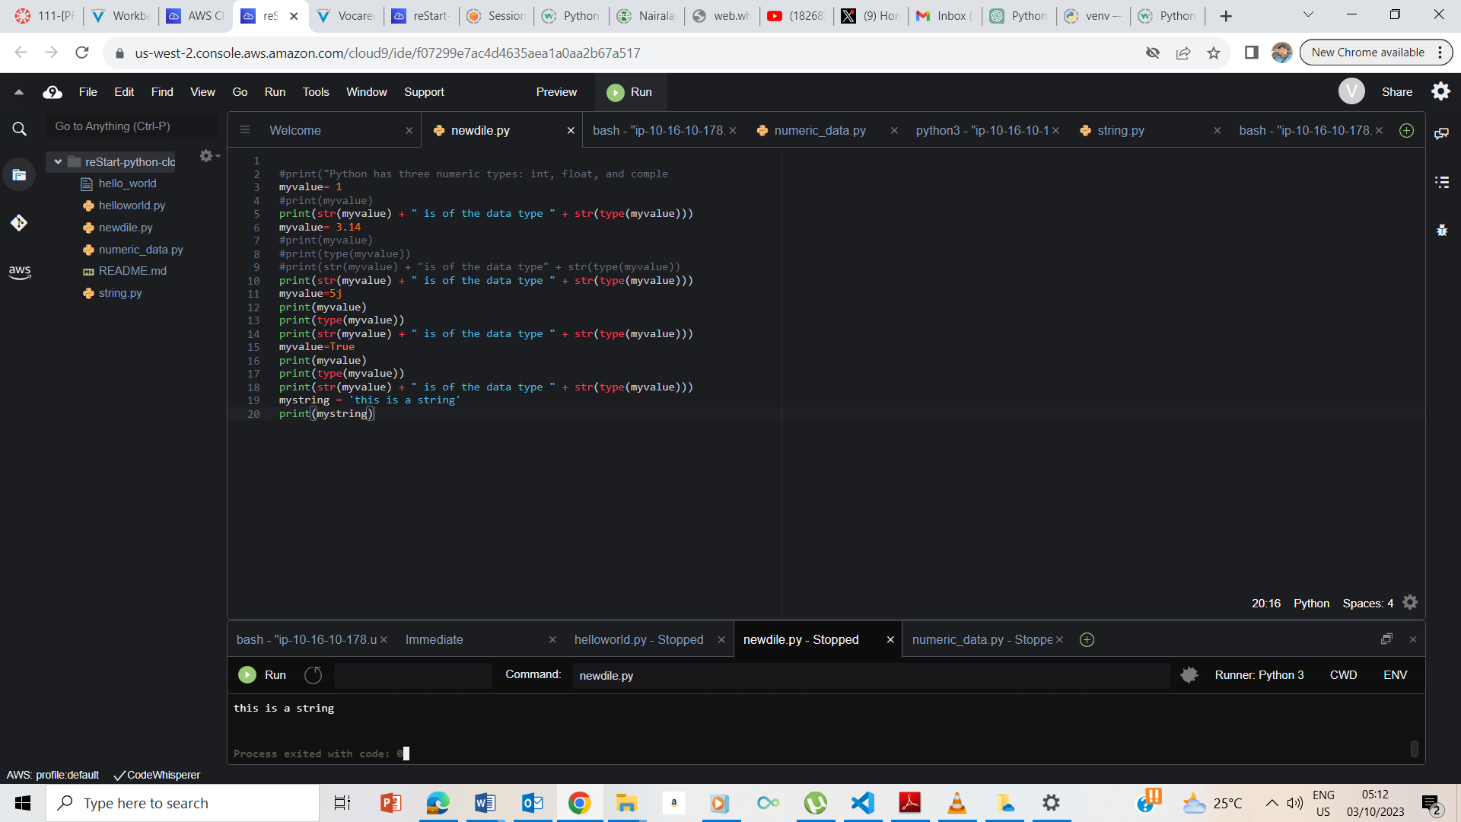

Outputting ‘This is a string’

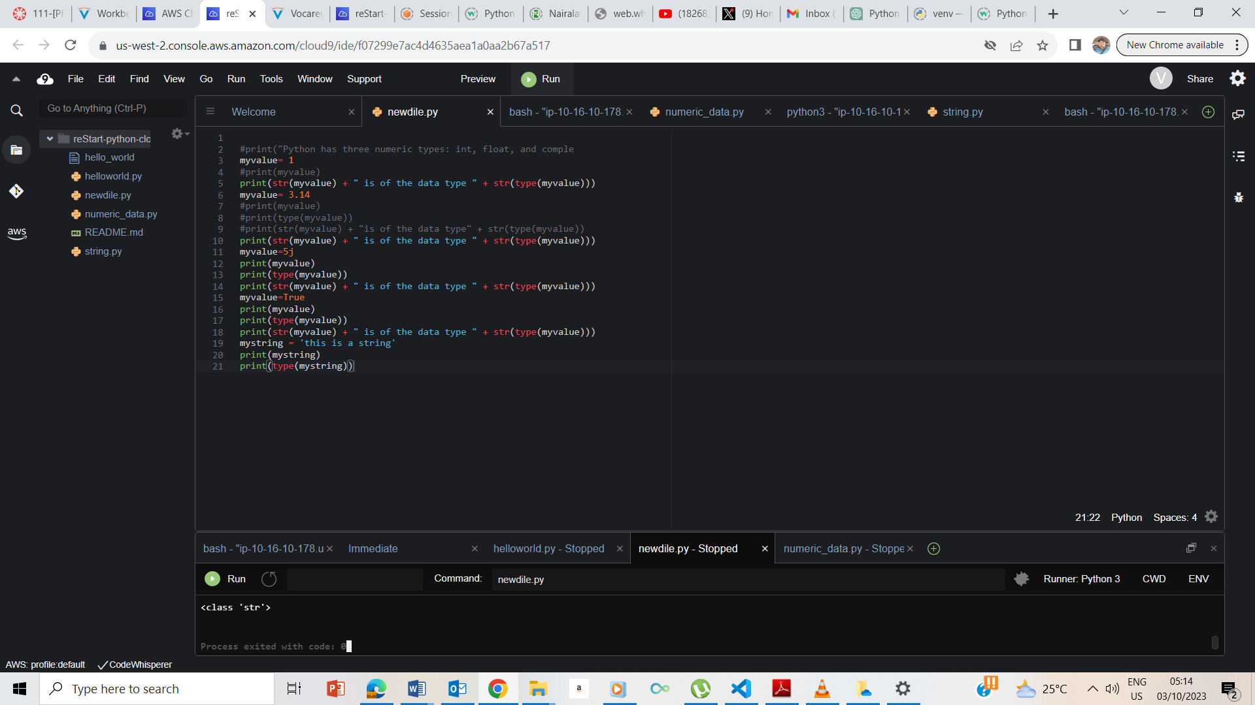

Print(type(mystring)) showing it is of class str

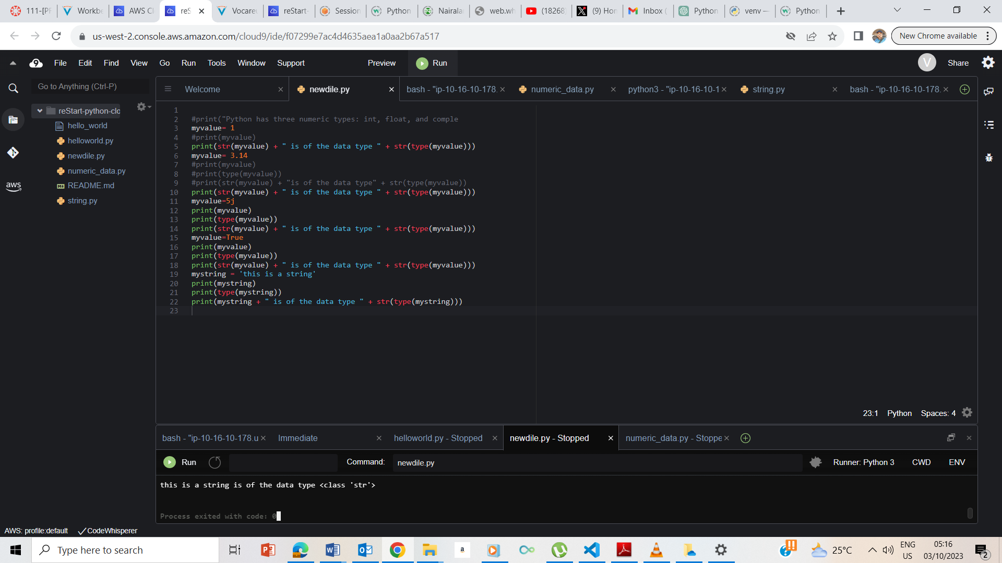

Showing the output of the instruction

1. **Exercise 2: Working with string concatenation** firstString = "water"
2. secondString = "fall"
3. thirdString = firstString + secondString
4. print(thirdString)

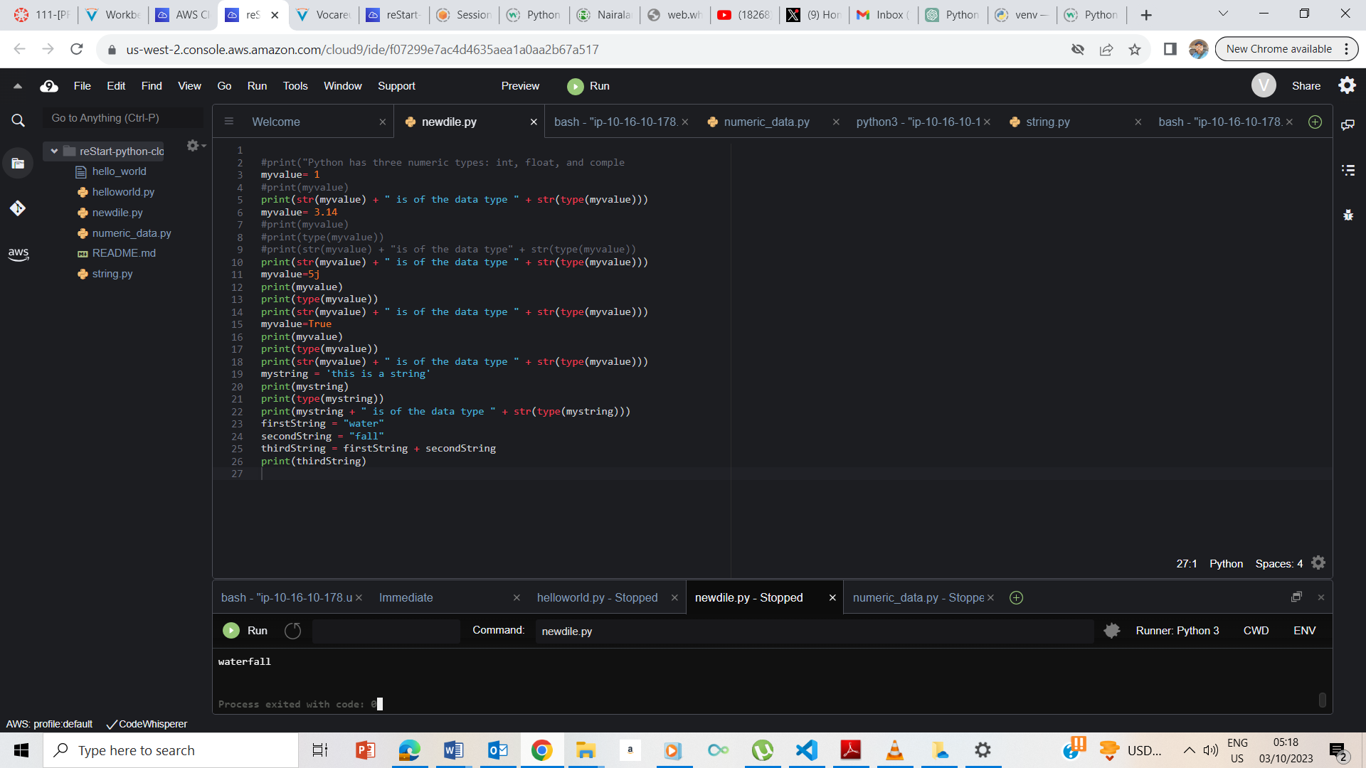

Result showing Waterfall

## **Exercise 3: Working with input strings**

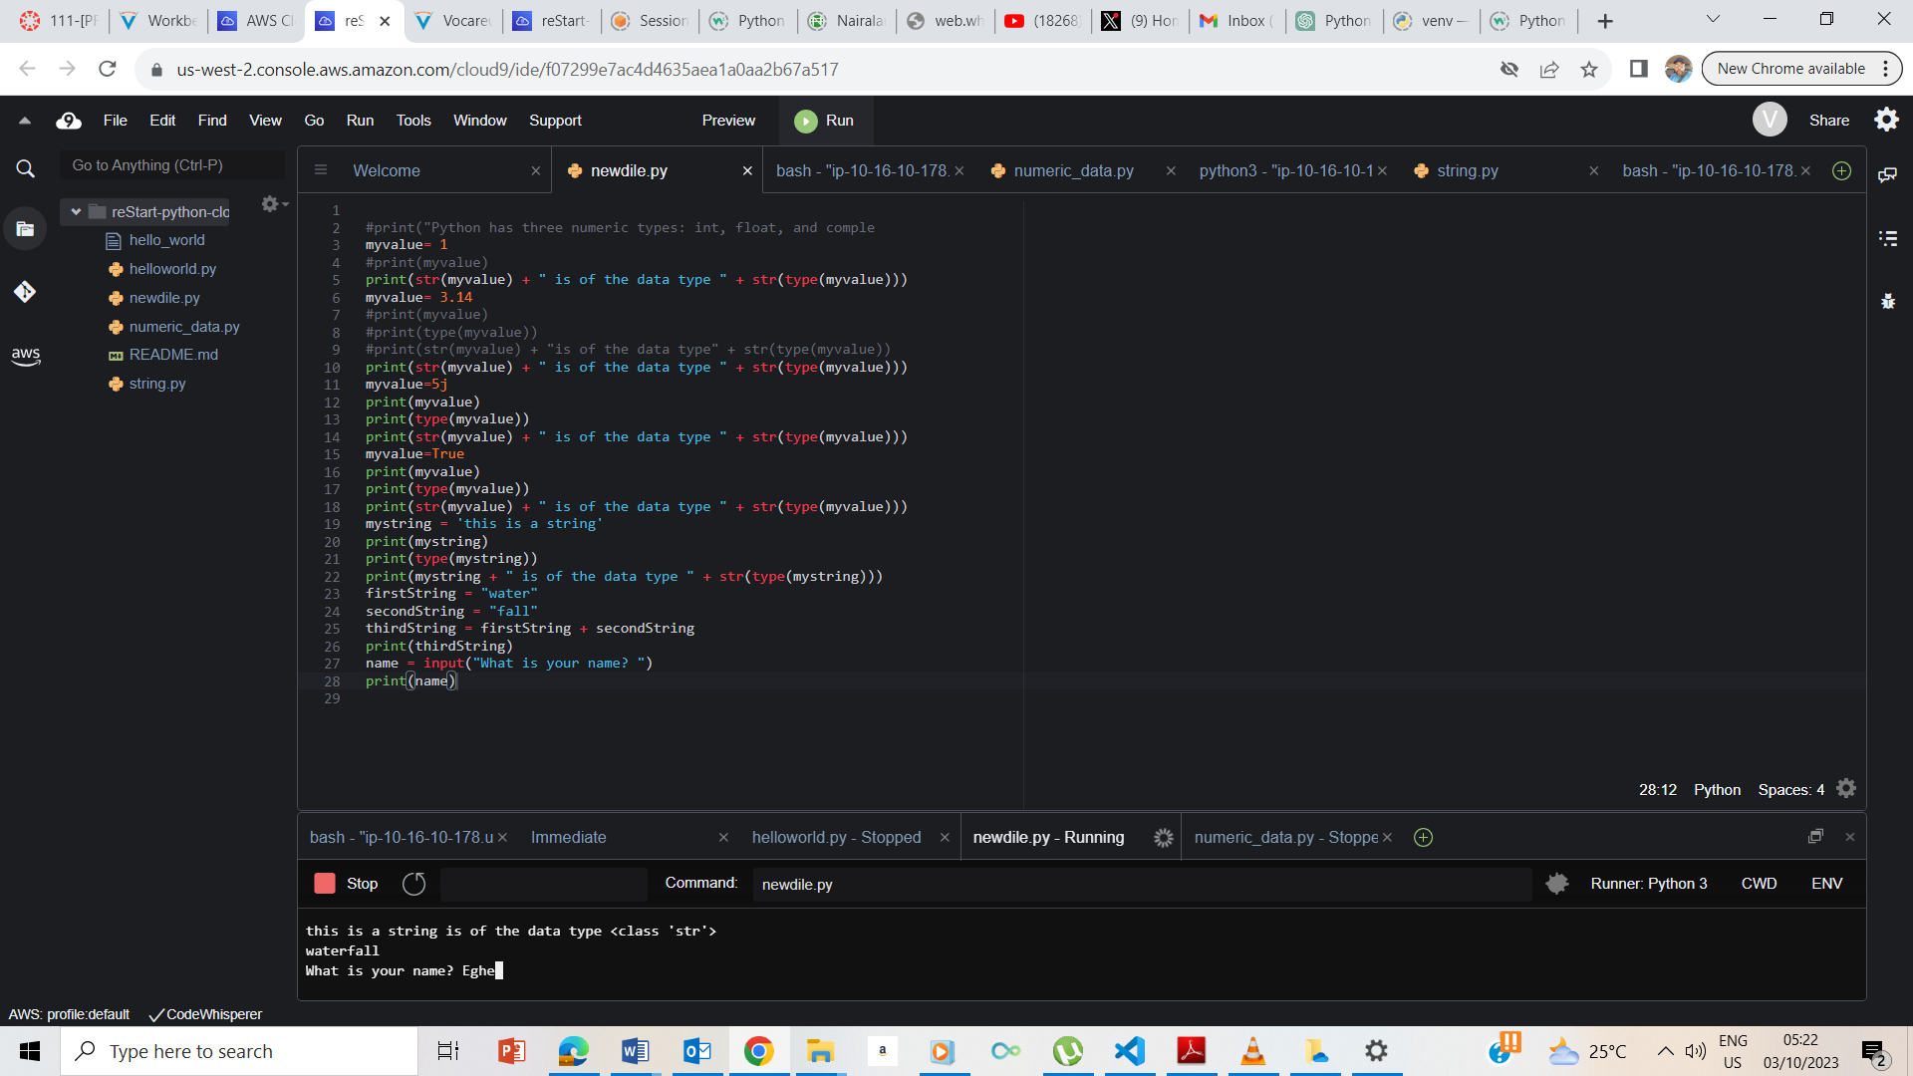

## **Exercise 4: Formatting output strings**

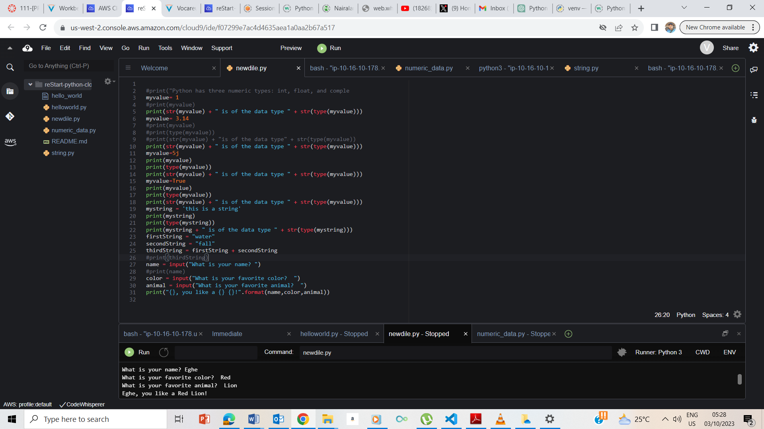

## **End Lab**

